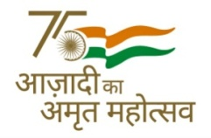 | 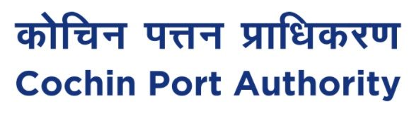 | 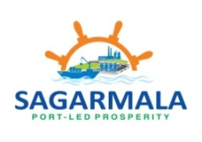
Press Release
Sagarmala - Seven Years of Spectacular Success
Ministry of Ports, Shipping and Waterways is commemorating the successful seven years of Sagarmala program, showcasing the exemplary performance, this flagship program of the Ministry has achieved during the last 7 years.
Sagarmala program was launched in March 2015 with the objectives to achieve port modernization & new port development, port connectivity enhancement, port-led industrialization and coastal community development. The program has followed a stepped approach of implementation with first attempt on implementing the maritime projects through Public Private Partnership (PPP) wherever feasible. Projects which have high social and economic quotient but low IRR are being implemented through funding support under the Sagarmala program.
The financial assistance is provided to State Governments and other MoPSW agencies for port infrastructure projects, coastal berth projects, Road & Rail projects, fishing harbours, skill development projects, Coastal community development, cruise terminal and unique projects such as Ro-Pax ferry services etc.
As highlighted by Shri Sarbananda Sonowal, Hon’ble Union Cabinet Minister, Ministry of Ports, Shipping and Waterways (MoPSW) under the visionary leadership of Prime Minister Shri Narendra Modi, the Sagarmala program was launched with the objective to improve ports’ efficiency. He said Quality service delivery has made Turnaround Time (containers) at Ports come down to 26.58 hours from 44.70 hours in 2013-14.
The report card of Ministry showcases 802 projects worth Rs.5.48 lakh Crore under the Sagarmala program targeted to be executed by 2035 out of which 194 projects worth Rs.99,000 Crore have been completed. A total of 29 projects worth Rs.45,000 Crore have been successfully implemented under PPP model, thus, reducing the financial burden on the exchequer. Further, there are 218 projects worth Rs.2.12 lakh Crore under construction and expected to be completed in 2 years’ time. This apart, 390 projects worth Rs.2.37 Lakh Crore are under development pipeline.
The skill centers developed under Sagarmala. Centre of Excellence in Maritime and Shipbuilding (CEMS) which has trained over 5000 candidates in 50+ courses since inception. National Technology Centre for Ports, Waterways and Coasts (NTCPWC) at IIT Madras has carried out more than 70 research and technical support projects related to ports and waterways. Centre for Inland and Coastal Maritime Technology (CICMT) at IIT Kharagpur has been set up to provide research, testing and experimentation facility to IWAI, shipyards and ports. Multi Skill Development Centres (MSDC) for training are already operational at the premises of Jawaharlal Nehru Port and Chennai Port Authorities in which 1200 candidates have been trained. Also, more than 35,000 candidates have undergone training at Safety Training and Welfare Institution, Alang. Additionally, Deen Dayal Upadhyay- Grameen Kaushalya Yojna Sagarmala Convergence Programme, under Ministry of Rural Development, to enable skilling of coastal population, trained more than 1,900 candidates, he added.
(PTO)

Port connectivity, another important element of the Sagarmala program, has 80 projects under its ambit. These include connectivity infrastructure projects, freight-friendly expressways to enable efficient movement of containers on key routes, and the development of strategic inland waterways. Port-led industrialization is being taken up with the aim to boost industrial and export growth along the coastline. This will be realized through 14 Coastal Economic Zones (CEZs) along the coastline. Another noteworthy initiative, development of a new deep draught port at Vadhavan, on the north coast of Maharashtra is taking shape. The port will cater to Ultra Large Container Vessels (UCLVs). Several steps are also being taken towards transitioning major ports to smart ports focusing on Port Community System; Logistics Data Bank Service; RFID Solutions; Enterprise Business Systems; Direct Port Delivery (DPD); Direct Port Entry (DPE); scanners/ container scanners and simplifying the procedures.
Projects in Cochin Port under Sagarmala scheme (attached).
(13.04.2022)

 | cochin_port |  | PortofCochin |  | portofcochin |  | company/portofcochin

www.cochinport.gov.in

